MS.NET\_MOCK\_Paper\_1\_0322

B:\IIT_ISDR\DAC\Paper Prep\Paper Prep 0921 NEW\Mock_Paper_0921\Dotnet_MOCK_NS_0921\Examination Screen_files\I_3_d.jpg

**1**

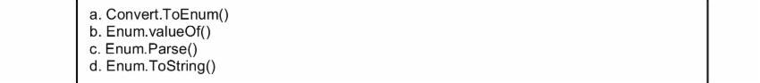

B:\IIT_ISDR\DAC\Paper Prep\Paper Prep 0921 NEW\Mock_Paper_0921\Dotnet_MOCK_NS_0921\Examination Screen_files\I_7_d.jpg

**2**

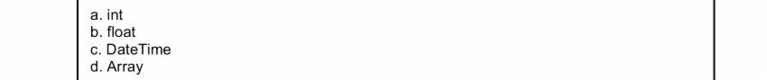

B:\IIT_ISDR\DAC\Paper Prep\Paper Prep 0921 NEW\Mock_Paper_0921\Dotnet_MOCK_NS_0921\Examination Screen_files\I_11_d.jpg

**3**

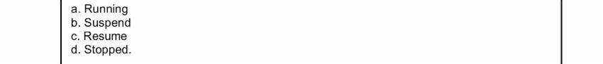

B:\IIT_ISDR\DAC\Paper Prep\Paper Prep 0921 NEW\Mock_Paper_0921\Dotnet_MOCK_NS_0921\Examination Screen_files\I_13_d.jpg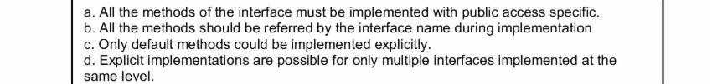

**4**

B:\IIT_ISDR\DAC\Paper Prep\Paper Prep 0921 NEW\Mock_Paper_0921\Dotnet_MOCK_NS_0921\Examination Screen_files\I_15_d.jpg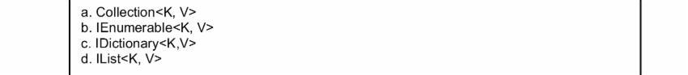B:\IIT_ISDR\DAC\Paper Prep\Paper Prep 0921 NEW\Mock_Paper_0921\Dotnet_MOCK_NS_0921\Examination Screen_files\I_17_d.jpg

**6**

**5**

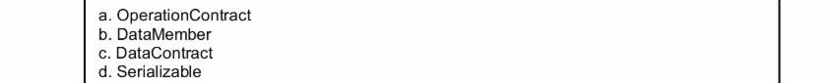B:\IIT_ISDR\DAC\Paper Prep\Paper Prep 0921 NEW\Mock_Paper_0921\Dotnet_MOCK_NS_0921\Examination Screen_files\I_19_d.jpg

**7**

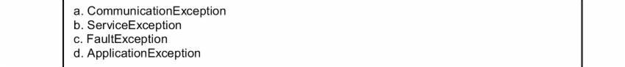

B:\IIT_ISDR\DAC\Paper Prep\Paper Prep 0921 NEW\Mock_Paper_0921\Dotnet_MOCK_NS_0921\Examination Screen_files\I_21_d.jpg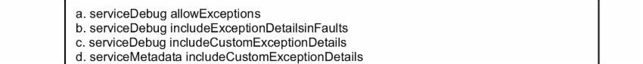

**8**

B:\IIT_ISDR\DAC\Paper Prep\Paper Prep 0921 NEW\Mock_Paper_0921\Dotnet_MOCK_NS_0921\Examination Screen_files\I_23_d.jpg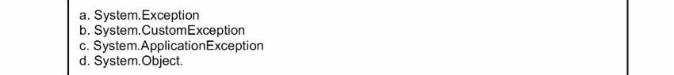

**9**

B:\IIT_ISDR\DAC\Paper Prep\Paper Prep 0921 NEW\Mock_Paper_0921\Dotnet_MOCK_NS_0921\Examination Screen_files\I_25_d.jpgB:\IIT_ISDR\DAC\Paper Prep\Paper Prep 0921 NEW\Mock_Paper_0921\Dotnet_MOCK_NS_0921\Examination Screen_files\I_27_d.jpg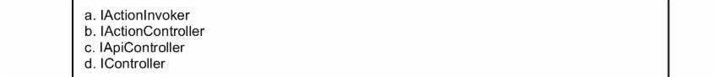B:\IIT_ISDR\DAC\Paper Prep\Paper Prep 0921 NEW\Mock_Paper_0921\Dotnet_MOCK_NS_0921\Examination Screen_files\I_29_d.jpg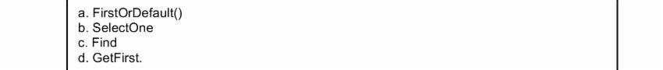B:\IIT_ISDR\DAC\Paper Prep\Paper Prep 0921 NEW\Mock_Paper_0921\Dotnet_MOCK_NS_0921\Examination Screen_files\I_31_d.jpg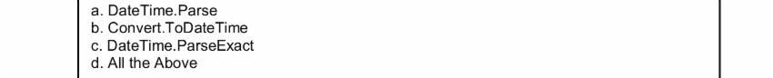B:\IIT_ISDR\DAC\Paper Prep\Paper Prep 0921 NEW\Mock_Paper_0921\Dotnet_MOCK_NS_0921\Examination Screen_files\I_33_d.jpg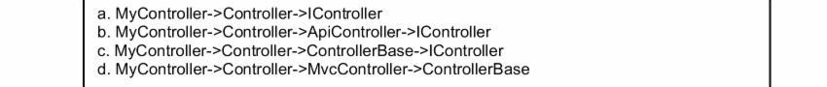B:\IIT_ISDR\DAC\Paper Prep\Paper Prep 0921 NEW\Mock_Paper_0921\Dotnet_MOCK_NS_0921\Examination Screen_files\I_35_d.jpg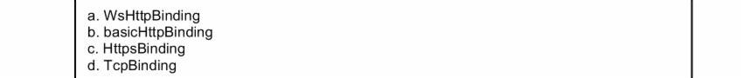

**15**

**14**

**13**

**12**

**11**

**10**

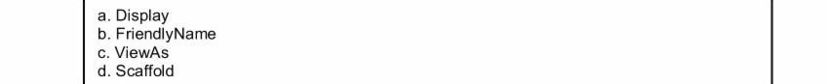

**16**



**17**

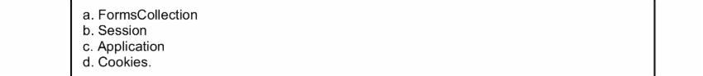

B:\IIT_ISDR\DAC\Paper Prep\Paper Prep 0921 NEW\Mock_Paper_0921\Dotnet_MOCK_NS_0921\Examination Screen_files\I_47_d.jpg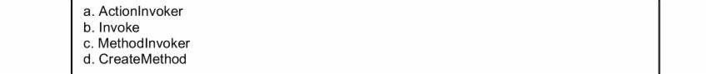

**18**

B:\IIT_ISDR\DAC\Paper Prep\Paper Prep 0921 NEW\Mock_Paper_0921\Dotnet_MOCK_NS_0921\Examination Screen_files\I_51_d.jpg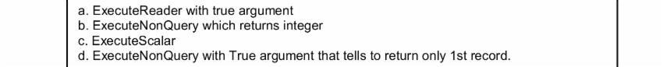

**19**

B:\IIT_ISDR\DAC\Paper Prep\Paper Prep 0921 NEW\Mock_Paper_0921\Dotnet_MOCK_NS_0921\Examination Screen_files\I_67_d.jpg

**20**

